


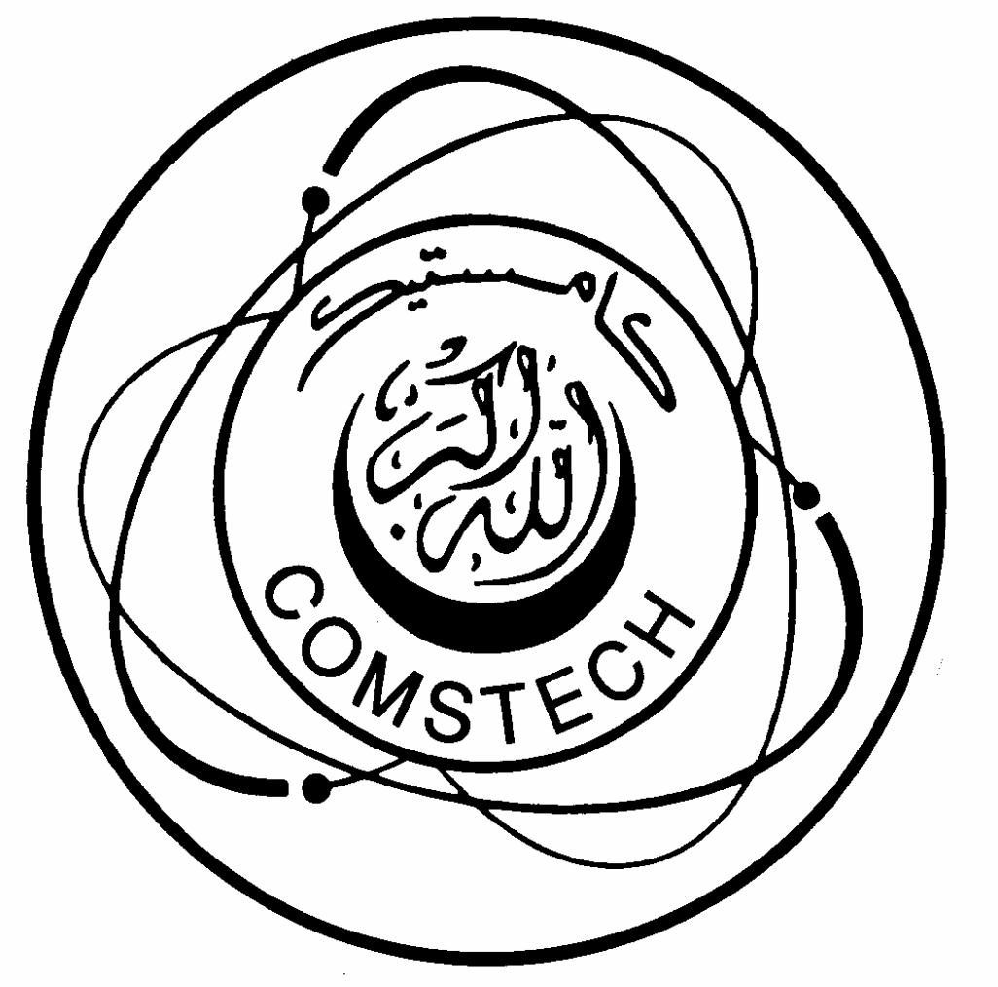
the academy of sciences for the developing world OIC Standing Committee on Scientific and
Technological Cooperation

COMSTECH-TWAS

JOINT RESEARCH GRANTS PROGRAMME
FOR
YOUNG SCIENTISTS
IN OIC COUNTRIES *

GUIDE
Applicants are advised to read this guide to ensure that they fulfil all the requirements in preparing
applications and are familiar with general policies and guidelines concerning grants.

General Information
TWAS, the academy of sciences for the developing world – www.twas.org – is an autonomous international organization founded in Trieste, Italy in 1983. Its principal aim is to promote scientific capacity and excellence for science-based development in the South.
The administration and financial operation of TWAS is undertaken by UNESCO in accordance with an agreement signed by the two organizations.
OIC Standing Committee on Scientific and Technological Cooperation (COMSTECH) – www.comstech.org – is an international organization based in Islamabad, Pakistan. Its principal aim is to promote the development of indigenous science and technology capability in OIC member states.
The COMSTECH-TWAS Joint Research Grants Programme is established in response to the needs of promising young researchers in OIC countries, particularly those attached to institutions that lack appropriate research facilities.
Under this scheme, individual researchers in OIC countries working in science and technology are awarded grants to enable them to purchase the research facilities they need to enhance their productivity.
The specific aims of the programme are to encourage the pursuit of scientific excellence in OIC countries by identifying and supporting the best young scientists in these countries; to reinforce and promote scientific research and to strengthen the endogenous capacity in science and technology; to counteract the brain drain and reduce the exodus of scientific talent from the OIC countries.
The COMSTECH-TWAS Joint Research Grants Programme complements the TWAS Research Grants Programme in Basic Sciences and the Research Grants Programme of the International Foundation for Science (IFS).
COMSTECH-TWAS Joint Research Grants are awarded to high-level and promising research projects carried out by young individual scientists in OIC countries.
A Research Grant amounts to a maximum of US$15,000.
A grant is normally provided for a period of 24 months and is renewable once.
A grant may be used to purchase scientific equipment, consumables and specialized literature (textbooks and proceedings only). The grant does not cover salaries of researchers and/or students, field expenses, travel expenses and/or participation in international conferences.

Subject Areas
The COMSTECH-TWAS Joint Research Grants programme provides support for research projects in the following fields of science and technology: earth sciences, engineering sciences, information technology and computer sciences, materials science including nanotechnology, pharmaceutical sciences and renewable energy.

Eligibility of Applicants
Individual applicants must be nationals of OIC Member States with a PhD and some research experience, though at the beginning of their careers. Women scientists are especially encouraged to apply. They should hold positions at universities or research institutions in one of the OIC countries. As a general rule, the grants are awarded to competent scientists under the age of 40 years.
Scientists who submit a satisfactory final report on a previous grant may apply for a renewal.

Agreement
A written agreement is made between TWAS, the grantee and his/her institute. The institute undertakes to administer the grant according to the agreement and to provide laboratory space, salaries and other facilities necessary for the project. Equipment, consumables and literature provided for the project through the COMSTECH-TWAS Joint Research Grants Programme remain the property of the institute after the project is completed.
The research grant is kept at TWAS for the purchase of all items requested by the grantee. TWAS contacts the supplier(s) upon receipt of proforma invoices submitted by the grantee in accordance with the itemized budget.
Awardees are required to submit a final report within one year of receipt of the last items purchased.

How to apply
The application must be submitted via the online form, the link to which can be found on the TWAS website.
A researcher may only submit one application at a time and for only one kind of grant (e.g. individual, research unit, or TWAS-COMSTECH) for consideration by TWAS.
For any queries please contact:
Ms P. Patel
TWAS — ICTP Campus — Strada Costiera 11 — 34151 Trieste — Italy
Phone: +39 040 2240493 — Fax: +39 040 224559 — E-mail: researchgrants@twas.org

When to apply
The deadline for receiving applications is 11 May 2017. However, we strongly recommend that you do not wait until the deadline but submit your application as early as you can.

Notification of TWAS decision
The COMSTECH-TWAS Joint Research Grants Committee will meet by February of the following year. Notification of the results will be made shortly afterwards.

* COUNTRIES ELIGIBLE FOR THE GRANTS
Afghanistan, Albania, Algeria, Azerbaijan, Bahrain, Bangladesh, Benin, Brunei, Burkina Faso, Cameroon, Chad, the
Comoros, Côte d'Ivoire, Djibouti, Egypt, Gabon, Gambia, Guinea, Guinea-Bissau, Guyana, Indonesia, Iran (I.R.), Iraq, Jordan, Kazakhstan, Kuwait, Kyrgyzstan, Lebanon, Libya, Madagascar, Malaysia, Maldives, Mali, Mauritania, Morocco, Mozambique, Niger, Nigeria, Oman, Pakistan, Palestine, Qatar, Saudi Arabia, Senegal, Sierra Leone, Somalia, Sudan, Suriname, Syria, Tajikistan, Togo, Tunisia, Turkey, Turkmenistan, Uganda, United Arab Emirates, Uzbekistan, Yemen.

