Press Release
ECO Science Foundation and ISTIC Malaysia join hands cooperation in the fields of science, technology and innovation

Economic Cooperation Organization Science Foundation (ECOSF) and International Science, Technology and Innovation Centre for South-South Cooperation Under the Auspices of UNESCO (ISTIC) Kuala Lumpur Malaysia signed a Memorandum of Understanding (MOU) for cooperation in the fields of Science, Technology and Innovation in the ECO Region on September 8, 2014 at Kuala Lampur Malaysia.

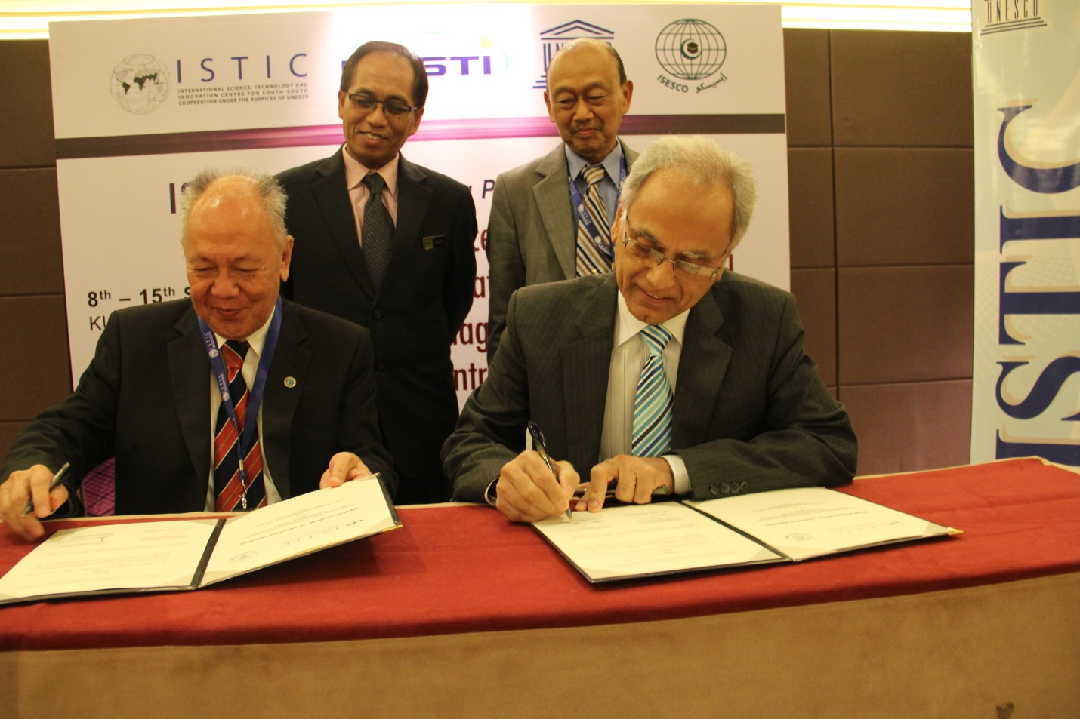

ECOSF President Prof. Dr. Manzoor H. Soomro signed the MOU, while on behalf of ISTIC, it was signed by the Chairman of ISTIC Governing Board Academician, Ir. Dato Yee Lee Cheong. The MOU will enable the two international organizations to work together for capacity building of the 10 ECO member states viz. Islamic Republic of Afghanistan, Republic of Azerbaijan, Islamic Republic of Iran, Republic of Kazakhstan, Kyrgyz Republic, Islamic Republic of Pakistan, Republic of Tajikistan, Republic of Turkey, Turkmenistan and Republic of Uzbekistan for S&T based economic development as per ECO Charter. The salient aspects of the MOU are:

    - Development and conduct of relevant capacity building activities, including training of skilled scientific and technical manpower, networks and linkages between government, academia and industry in and between their respective member countries.
    - Supporting the exchange of researchers, scientists, engineers and technologists among member countries
    - Facilitation of information transfer between their respective member countries by both the public and private sectors.
    - Designing programmes to strengthen the scientific, engineering and research and development institutions.
    - Surveys of problem areas faced by member countries in technology, and technology assessment for individual member states and facilitating technology transfer.
    - Holding of science and technology fairs and exhibitions in collaboration with member states
    - Grant of awards and prizes to eminent scientists in the fields of science, technology and innovation.
    - Streamlining and harmonizing of STI policies.
    - Capacity Building of ECO Region in Inquiry Based Science Education (IBSE)
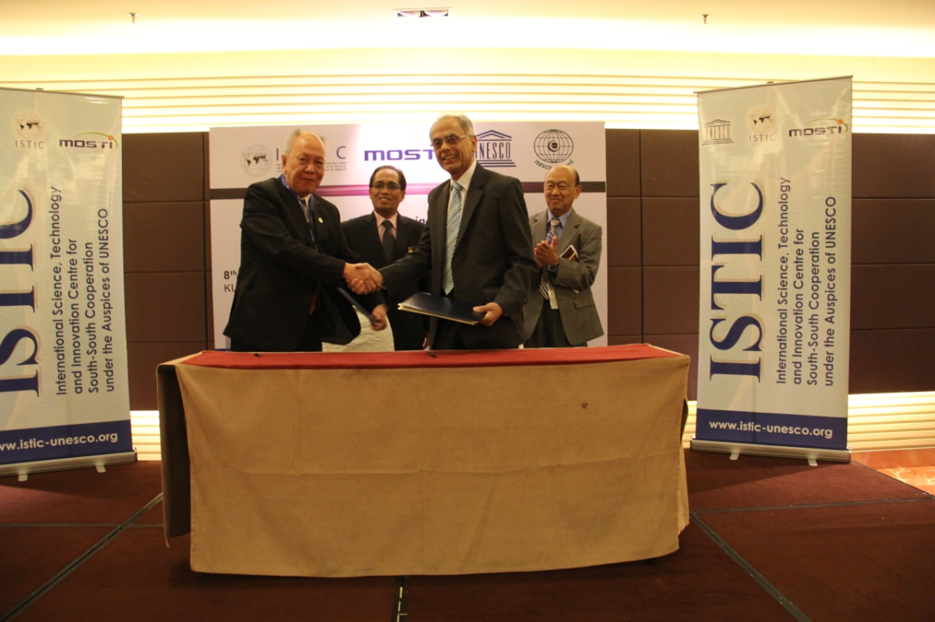

ISTIC and ECOSF will act in close cooperation and consult each other on a regular basis, to review the progress under this Memorandum, on issues of common interest, including joint projects and other activities at the international, regional and national levels, in order to coordinate their work and strengthen cooperation. ISTIC and ECOSF may enter into separate agreements to document each of their rights, benefits and obligations in respect of each specific project/programme that they may wish to jointly undertake during the term of this Memorandum.
ISTIC is a category 2 Centre under the auspices of UNESCO meant for implementing a programme for South-South Cooperation among the group of 77 developing countries in fields of Science, Technology and Innovation leading to economic development.
-------------------

